Class Diagram

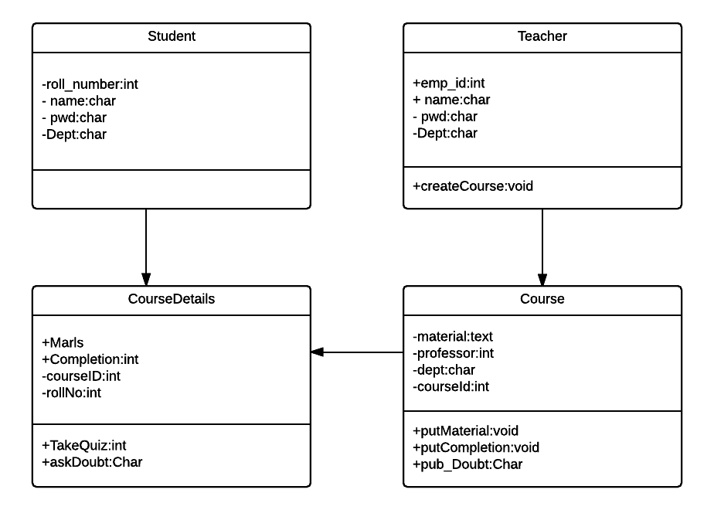

There are 4 Objects

1. Student
2. Teacher
3. Course
4. CourseDetail

The Course Object is created by Teacher and saves the course materials, etc. A courseDetail Object is created when a student logs into a course and saves the process of the student in the course.